**AMAZON KINESIS**

Amazon Kinesis is a well-organized, expandable cloud-based service. It gives permission the actual time, preparing the stream of huge data every minute. It is constructed for actual-time applications and also permits the developers to grab the quantity of the data by the numerous resources. One can move up and down on EC2 instances. We can use it to gather, save, and proceed with the data and assign flood-like occasion logs and forage of social media. It is assigned to different customers simultaneously after proceeding with the data.

METHOD TO UTILISE AMAZON KCL

One can use Amazon KCL, when in need of transferring the data instantly and for frequent proceeding.

* Protect the data

When the data is generated, we can collect the data or pass the data to an Amazon Kinesis flood soon. We can protect our lost data when the data organizer fails. For example, the application records and systems are frequently attached to the stream and we can access instantly at any time we need.

* Removal of actual time graph

We can generate the outcome of the records by using the Amazon Kinesis stream. We can remove the graphs as well. And most importantly, we don’t have to wait to collect the data.

* Well-organized real-time data

We can run the actual time data systematically using Amazon Kinesis.

**BOUNDARIES OF AMAZON KINESIS**

* The reports of the stream data are available for 24 hours and it can be increased for more than 7 days by permitting increased data confinement, by default.
* The maximum size of the data blob is 1 megabyte in a single report.
* Up to 1000 PUT reports, every second is held by one shard.

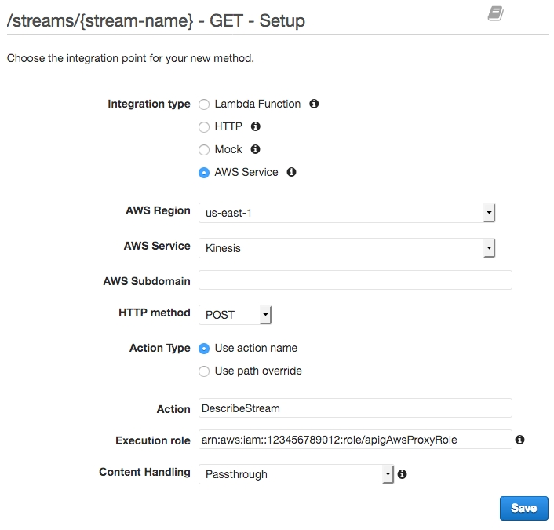

**METHOD TO USE AMAZON KINESIS**

**First step**

* Setting the Kinesis stream
* Firstly, you have to sign in to account of AWS.
* Go to “Amazon management console”.
* Choose “Amazon kinesis”.
* Now click on “create a stream” and fill in the information in the boxes given. (Such as your name and number of shards etc.)
* Click on “create” option.
* Now you can see the stream in the stream list.

**Second step**

* Please stay on the Kinesis stream to set up the users.
* Generate a new user.
* Distribute the plans to new user.

**Third step**

* Correlate your application with Amazon Kinesis.
* Sign in to Zoomdata.
* Go to the menu bar and click on “sources”.
* Select the icon of kinesis.
* Now fill in the details carefully.
* Click on the “next” option.
* Go to the stream option and choose the desired stream.
* Go to the field option.
* Generate the special label name.
* Click on next option.
* Go to the charts options and allow charts for data.
* Design the setting as per your need.
* N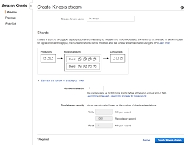ow save the setting by clicking on the “finish” option.

**FEATURES OF AMAZON KINESIS**

* Actual time management :- It provides permission to gather and examine the details in actual time such as regular commercial prices.
* Convenient to use :- We can generate a fresh stream with the help of Amazon Kinesis.
* Combination with the services of Amazon :- Amazon Redshift, Amazon s3, Amazon DynamoDB can be combined with the Amazon Kinesis.
* Construct the application of Kinesis :- It provides the developers with the customer libraries which allows to structure and function the actual time data processing applications. We will receive the declaration of fresh data by attaching the Amazon Kinesis client library to Java application for proceeding further.
* Affordable prices :- Amazon Kinesis is very cost-effective. We can pay according to our needs and requirements. Thus it becomes easy to manage the work pressure of any scope.

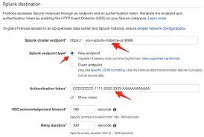

HOW DOES AMAZON KINESIS WORK?

Amazon kinesis permits to consume the actual time data taken from various sources like records of applications and clickstreams of websites. And pattern it for the details and data warehouses. To utilize Amazon Kinesis, we need to construct a Kinesis stream. Kinesis is for getting data on time and to perform rapidly for fresh information and outcomes.

[AWS Training in Bangalore](https://www.apponix.com/AWS-Essentials-Solutions-Architect/AWS-solution-arcchitect-training-in-bangalore.html)